**Lab-01**

**Objective: To learn creation of datagram sockets using Socket Programming**

1. **Modify the sample code so that the sender uses the same socket to send the same message to two different receivers. Start the two receivers first, then the sender. Does each receiver receive the message? Capture the code and output. Describe the outcome.**

**Code:**

**ExampleSender.java**

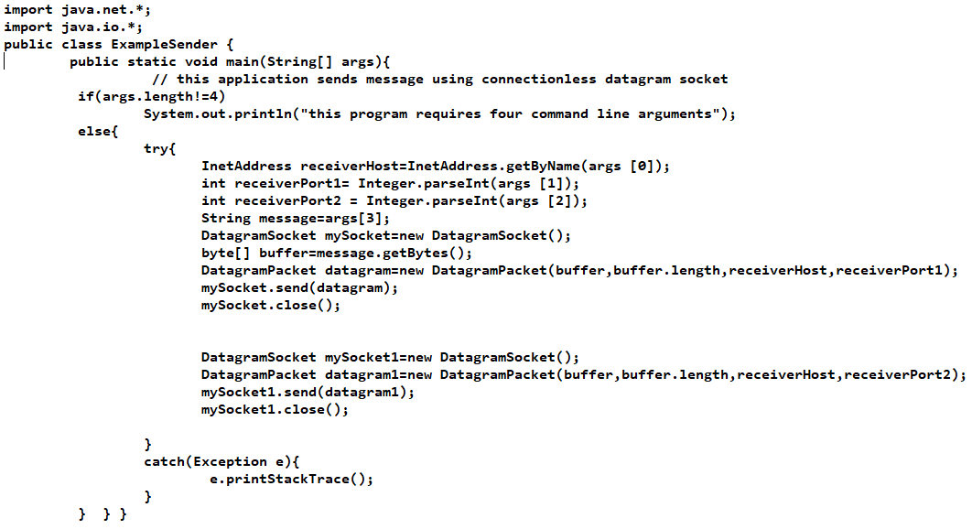

**ExampleReceiver.java**

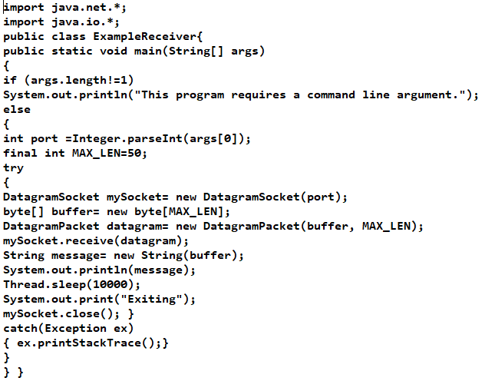

**ExampleReceiver2.java**

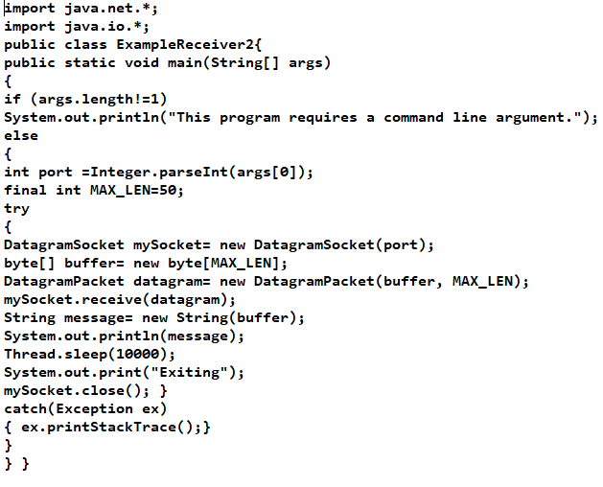

**Output:**

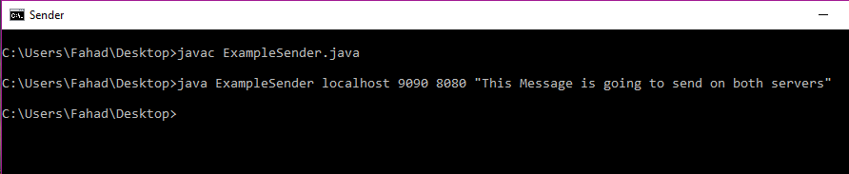

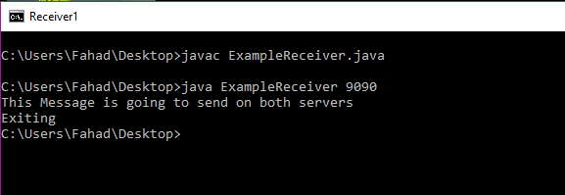

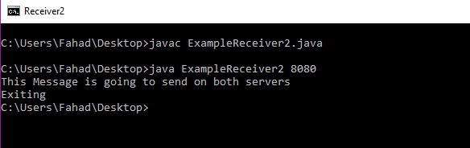

1. **Modify the sample code so that the receiver loops five times to repeatedly receive then display your bio data (name, roll num etc.) received. Recompile. Then  
   i. Start the receiver  
   ii. Execute the sender, sending your bio data, and  
   iii. In another window, start another instance of the sender, sending your friend’s bio data. Does the receiver receive both the messages? Capture the code and output.**

**Code:**

**SenderTask.java**

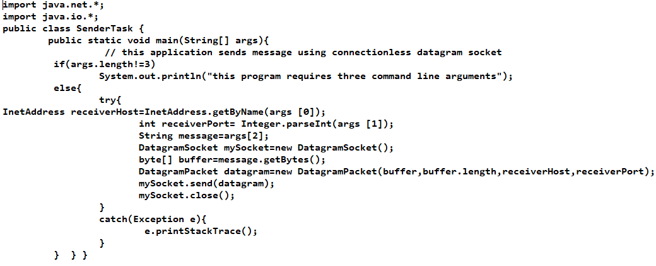

**ReceiverTask.java**

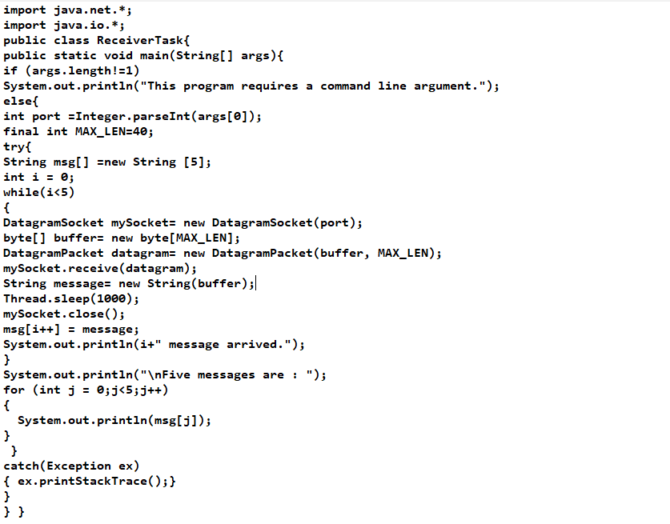

**Output:**

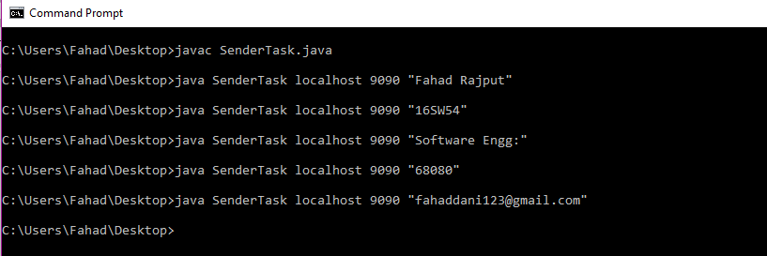

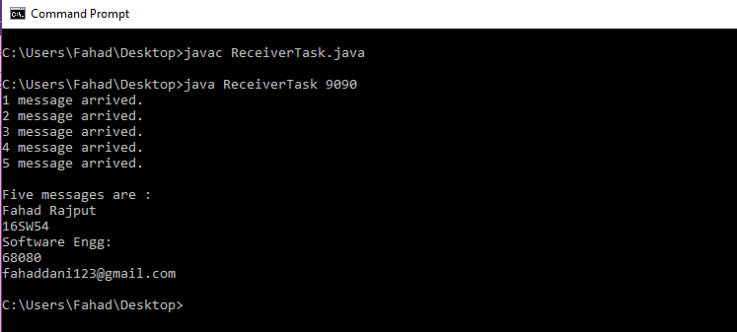

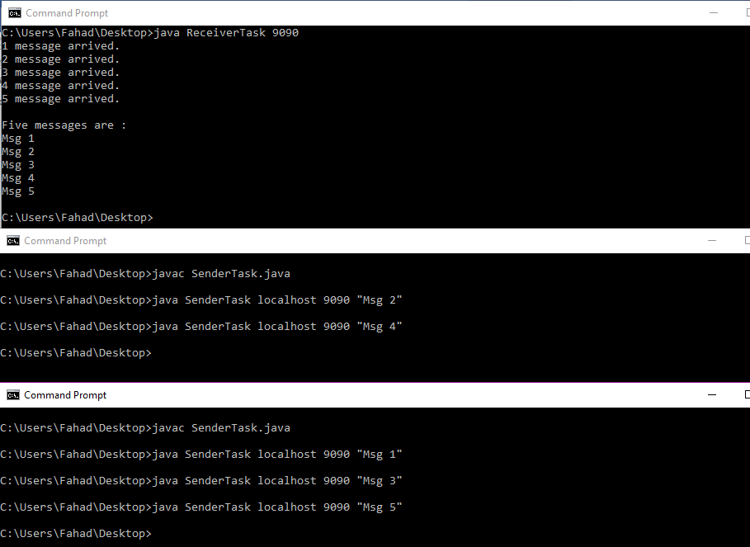

1. **Modify the sample code to cater to a two-way communication i.e. Sender sends a message to the Receiver, the Receiver receives the message and sends a reply to the Sender in return.**

**Code:**

**Client Class:**

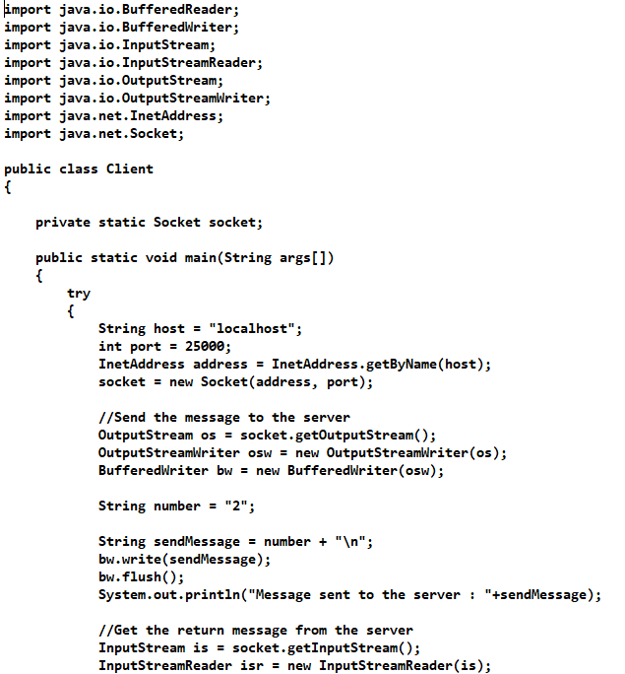

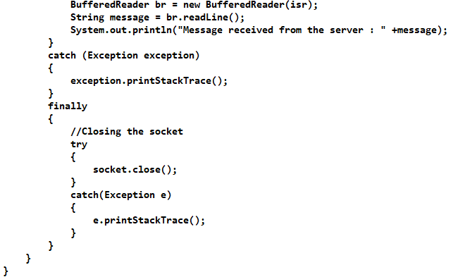

**Server Class:**

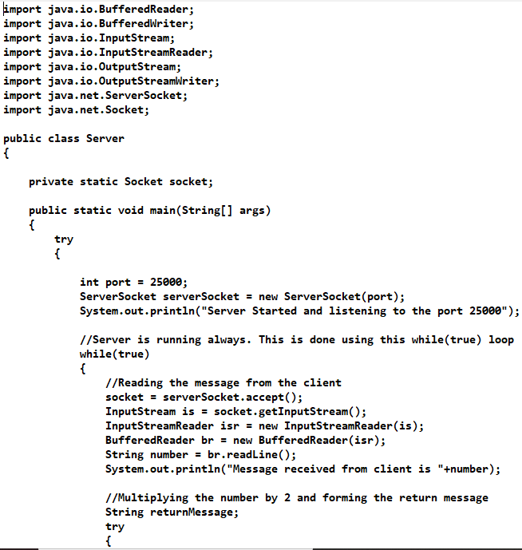

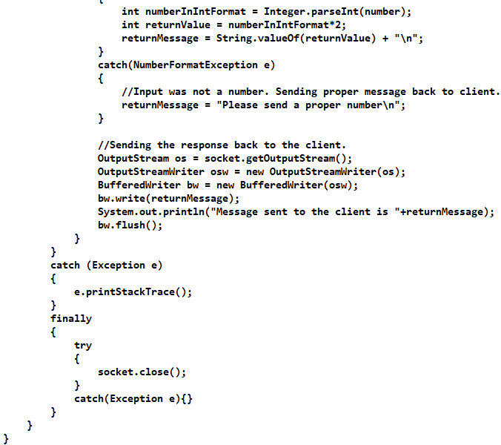

**Output:**

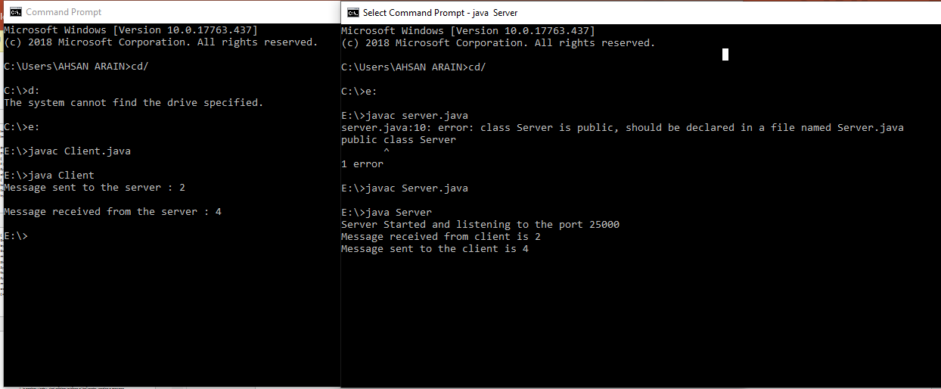

1. **Broadcasting: Broadcasting is a one-to-all type of communication, i.e. the intention is to send the datagram to all the nodes in the network. Unlike in the case of point-to-point communication, we don’t have to know the target host’s IP Address. Instead, a broadcast address is used.**

**Implement two simple programs using Java datagram sockets, which broadcasts and multicast your roll number to all or selected network nodes respectively.**

**Code:**

**BroadcastClient.java**

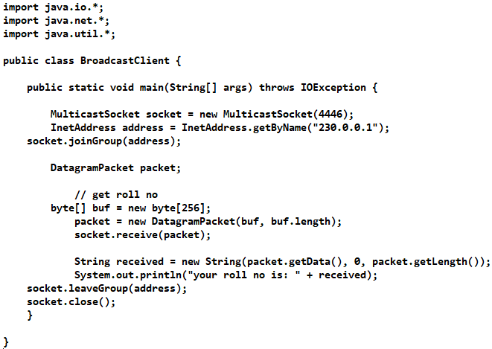

**BroadcastSever.java**

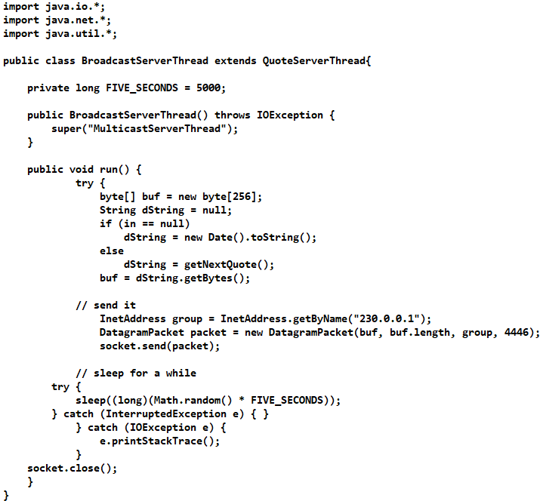

**QuoteServerThread.java**

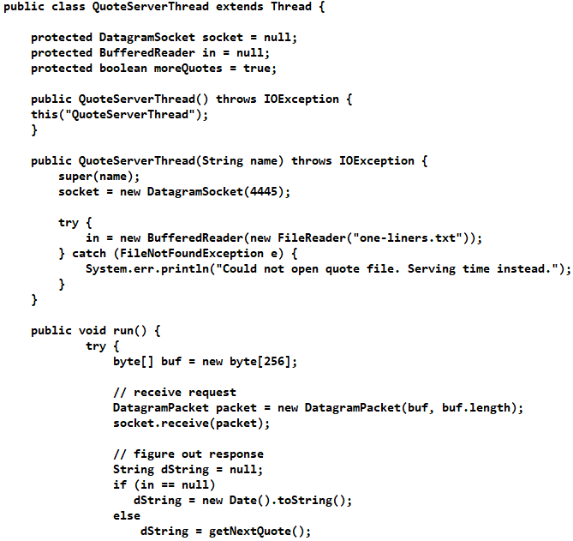

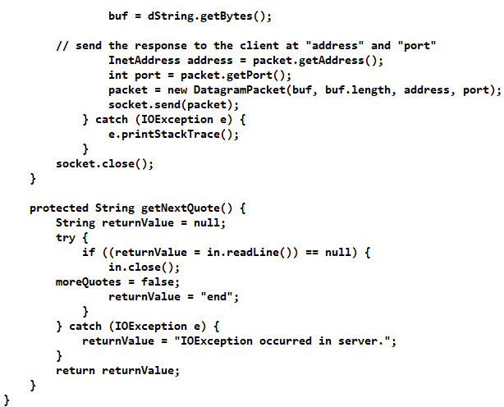

1. **Multicasting: Broadcasting is inefficient as packets are sent to all nodes in the network, irrespective of whether they are interested in receiving the communication or not. This may be a waste of resources. Multicasting sends packets to only those nodes which are interested. Multicasting is based on a group membership concept, where a multicast address represents each group.**

**Code:**

**UDPMulticastClient.java**

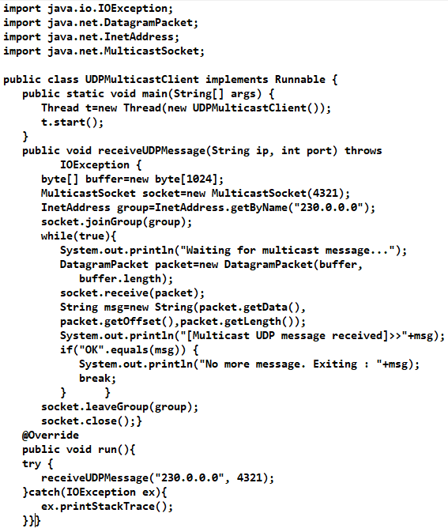

**UDPMulticastServer.java**